SUSTAINABLE RIVERS PROGRAM
USACE MOBILE DISTRICT
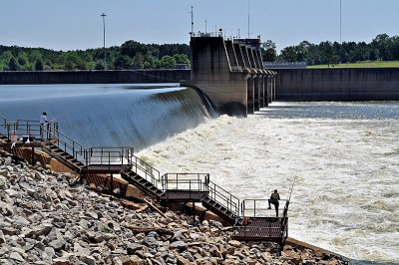

MILLERS FERRY AND CLAIBORNE LOCKS AND DAMS
ALABAMA RIVER
FY 2023 Summary and Baseline Report
Terry W. Rickey Jr., Jason Thornberry, Cal Johnson,
Pat O’Neal







Executive Summary

Introduction: The Claiborne and Millers Ferry Locks and Dams have fragmented the Alabama River for over 50 years, impacting its aquatic ecosystem. This report details the findings of the Fiscal Year 2023 (FY23) baseline characterization study, a multi-agency effort designed to provide a comprehensive, quantitative "snapshot" of the river's ecological state prior to targeted fish passage investigations.
Methods: With foundational data provided by the Geological Survey of Alabama (GSA), this study utilized a multi-gear sampling approach to inventory the fish community across three major river reaches: Downstream of Claiborne L&D, Between the Dams (Claiborne Pool), and Upstream of Millers Ferry L&D. Methodologies included standardized boat electrofishing following the USGS IBI protocol (O'Neil et al., 2013), targeted river trawling over historical gravel bars, and large-seine sampling in shallow-water habitats.
Key Findings: The validated dataset comprises 33,926 individuals and provides a clear diagnosis of a fragmented river system.
A Reservoir of Biodiversity Downstream: The unimpounded, free-flowing reach below Claiborne Dam supports the highest species richness (S=41) and the most robust population of resident sport fish.
An Impoundment Effect on Abundance: The first impoundment ("Between Dams") exhibited hyper-abundance (N=25,411), driven by massive catches of a few small-bodied forage species thriving in the lake-like environment.
A Cumulative Decline in Diversity Upstream: The reach above Millers Ferry Dam had the lowest total abundance and the lowest biodiversity (Shannon Index H=1.22), demonstrating the cumulative negative impact of the dams on ecological balance.
Discovery of Resilient Specialist Populations: Targeted trawling successfully documented the presence of the rare Crystal Darter, confirming that critical submerged gravel bar habitats remain ecologically functional.
Conclusion: The FY23 baseline study quantitatively confirms that the Alabama River is a system defined by fragmentation, where impoundment has led to a dramatic loss of biodiversity and a shift in community structure away from a natural, balanced riverine ecosystem. This report establishes the definitive "before" picture and provides the unambiguous scientific justification for the subsequent SRP studies aimed at restoring ecological connectivity.

Table of Contents
Introduction 5
Alabama River 5
Current Dam Operations and Conservation Practices 6
Alabama River Lockages Sustainable Rivers Project 8
Data Gathering 10
Key Target Species and Guilds 10
1. Migratory "Big-River" Species 10
2. Resident Sport Fish 10
3. Benthic Specialists of Conservation Concern 10
4. Forage Fish Community 11
Electrofishing 11
Method 11
Target Species/Groups 12
Site Selection 12
Gravel Bar Seining 13
Method 13
Site Selection 14
Target Species/Groups 15
Results 15
Trawling 15
Method 15
Target Species/Groups 16
Site Selection 16
Results 17
Data Analysis 17
Calculation of Biodiversity Indices 17
Interpretation of Final Verified Results 18
Discussion 19
Individuals Collected 20
Biodiversity Indices as a Measure of Community Structure and Balance 21
Discussion and Interpretation of Guild Analysis 25
Future Application of this Baseline Analysis 26
The applications of this baseline are threefold: 26
Future Direction 27
Appendix 29
Species Classification by Primary Fish Guild 34

Table of Figure
Figure 1: Conceptual project development schedule for the Alabama River Lockage Study. The project follows a phased approach, beginning with a Baseline Assessment (FY23), followed by Experimental Lockages (FY24-25) to test passage solutions, and culminating in Integration (FY26) where successful findings are incorporated into updated District Standard Operating Procedures (SOPs). 9
Figure 2: ADEM Biologist with fish captured during electrofishing efforts in June of 2023, USACE. 12
Figure 3: Sites sampled by electrofishing in FY 23. 13
Figure 3: TNC, ADEM, and GSA biologist conduction beach seining in the Fall of 2023, TNC. 14
Figure 5: Sites sampled by seining in FY 23. 15
Figure 4: L: USACE and USFWS Biologist conducting a river trawl over a gravel bar in November of 2023. R: ADEM, TNC, and GSA biologists assessing fishes capture in November 2023, USACE. 16
Figure 7: Sites sampled by trawling in FY 23. 17
Figure 8: Total species collected in each reach. 20
Figure 9: Total individuals collected in each reach. 21
Figure 10: The Shannon Biodiversity Index for each Reach. 22
Figure 11: The Stimpson Biodiversity Index for each Reach. 23
Figure 12: The guild composition of each reach. 26

Introduction
The goal and mission of the Sustainable Rivers Program (SRP) is to improve the health and life of rivers by changing operations of U.S. Army Corps of Engineers (USCAE) water resource infrastructure to restore and protect ecosystems, while maintaining or enhancing other project benefits (USACE/ TNC, 2021).

Alabama River
The Mobile River Basin forms the fourth-largest basin in the nation and encompasses portions of 43,662 square miles in portions of Alabama, Georgia, Mississippi, and Tennessee (Figure 1). The Mobile River, formed by the Alabama and Tombigbee Rivers, flows south for approximately 45 miles to Alabama’s gulf coast. Together the basin supports a high diversity of aquatic species (fishes, mussels, snails, crayfishes, amphibians and reptiles) and bottomland habitats. The Alabama River flows for 315 miles and encompasses a 22,800 square mile drainage (Figure 1). The Alabama River itself supports over 180 fish species with a relatively high proportion of endemic species.

Claiborne and Millers Ferry Locks and Dams are located on the Alabama River at river miles (RM) 72.5 and 133, respectively. These are the lowermost dams on the Alabama River and are operated by the U.S. Army Corps of Engineers (USACE) Mobile District, with authorized missions for navigation, recreation, and fish and wildlife conservation.

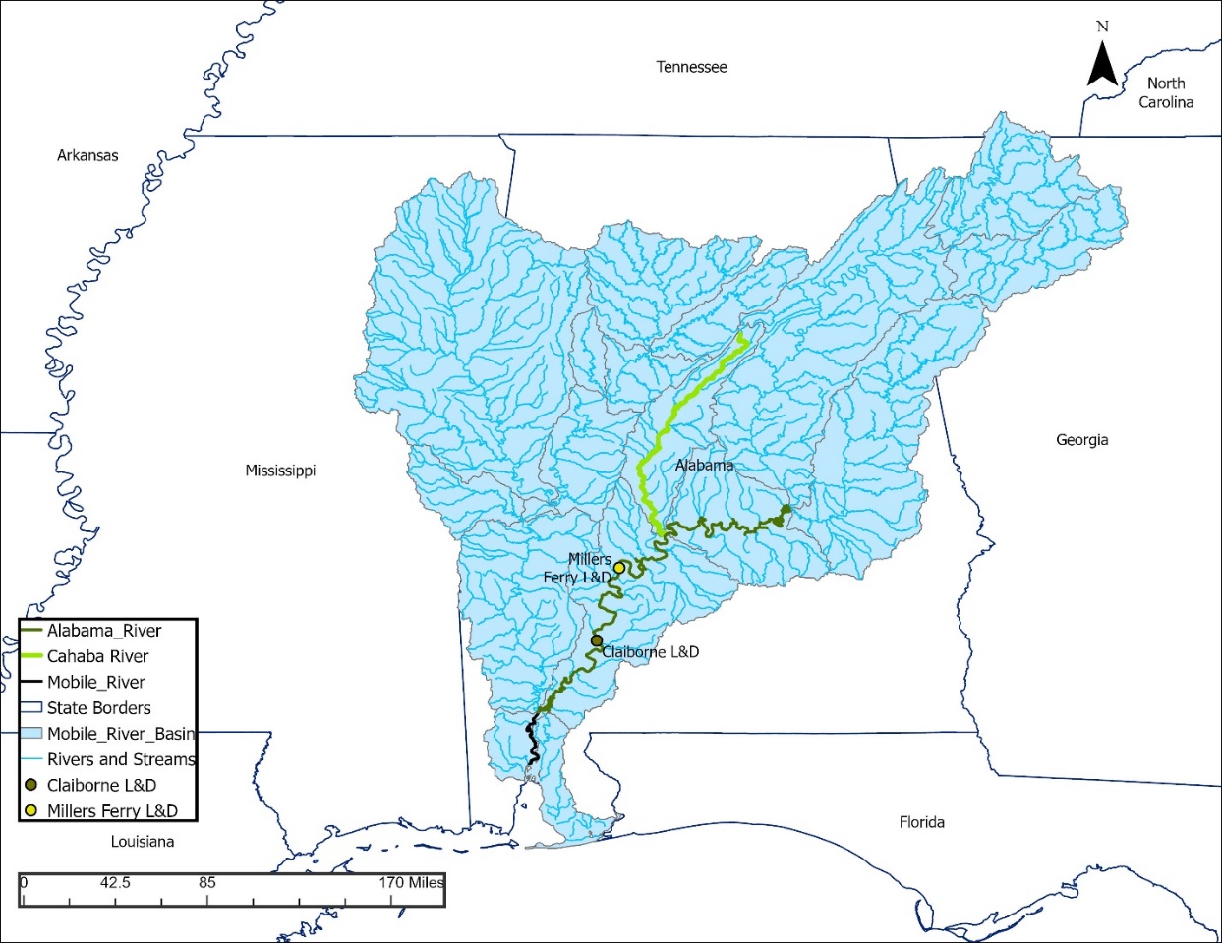
Figure 1: Mobile River basin with project locks and dams on the Alabama River.

The Alabama River has undergone extensive physical and hydrological alterations due to the construction of Claiborne and Millers Ferry L&Ds. The result is a disconnected river system between the Alabama and Cahaba rivers that inhibits migratory movement of Federally listed species such as Alabama and Gulf Sturgeons along with non-listed fishes . The decline of spawning populations of fish species, many of which serve as host species for freshwater mussels, is a contributing factor to the Federal listing of numerous mussel species above Millers Ferry LD.
The Alabama River, a principal tributary of the Mobile River Basin, is a recognized global biodiversity hotspot that historically supported a dynamic, large-river fish assemblage. Archival research (Hershey et al., 2024) has revealed that the pre-impoundment river was defined by massive, seasonal fish "runs," where potamodromous species like sturgeon, shad, and buffalo migrated far upstream in response to the annual spring flood pulse. This unimpeded connectivity was a keystone ecological process for the entire system.
For over 50 years, this natural function has been fundamentally altered by the construction of the Claiborne and Millers Ferry Locks and Dams. Foundational ichthyological surveys of the region (e.g., Mettee et al.) have documented the profound impact of this fragmentation, noting the decline of fluvial specialists and a shift in community composition. However, a modern, comprehensive, and quantitative baseline assessment was needed to understand the river's current ecological state and to provide a scientifically defensible foundation for any future restoration actions.

Current Dam Operations and Conservation Practices
The Claiborne and Millers Ferry Locks and Dams are multi-purpose projects managed by the U.S. Army Corps of Engineers (USACE), Mobile District. Their primary authorized purpose is to maintain a navigable waterway on the lower Alabama River. However, their operational mandate also includes considerations for hydropower generation (at Millers Ferry/B. F. Dannelly) and fish and wildlife conservation.
Normal Navigation Operations
Under normal operations, the lock chambers at both Claiborne and Millers Ferry are operated strictly "on demand" for commercial and recreational vessel traffic.
- A vessel approaching the dam radios the lock operator.
- The lock operator initiates a "lockage cycle": the chamber is either filled or drained to match the water level of the vessel's approach.
- The miter gates open, the vessel enters the chamber, the gates close, and the water level is raised or lowered to match the level of the other side.
- The opposing miter gates open, and the vessel exits.
This process is entirely dependent on vessel traffic. During periods of low to no navigation, the lock gates remain closed, and the chamber remains static for extended periods, creating a complete barrier to fish movement.
Existing Conservation Lockage Operations
Recognizing the dams' impact on fish migration, the USACE Mobile District, in coordination with conservation agencies, has previously implemented a practice known as "Conservation Lockages." This practice represents a proactive, non-structural effort to facilitate fish passage using the existing navigation infrastructure.
A conservation lockage is a lockage cycle performed for the express purpose of moving fish, not vessels.
How it Differs from Normal Operations:
The key difference is intent and initiation. Instead of being triggered by a boat, a conservation lockage is initiated by a lock operator based on a pre-determined general understanding of migratory seasons. The process typically involves:
- Lowering the water level in the lock chamber to match the downstream (tailwater) level.
- Opening the downstream miter gates for a designated period, allowing the fish aggregated in the tailwater to swim into the lock chamber, attracted by the flow.
- Closing the downstream gates and filling the chamber to the upstream (headwater) level.
- Opening the upstream miter gates, allowing the fish to exit into the upstream reach.
Seasonality and Conditions:
Historically, these conservation lockages have been performed based on a general seasonal understanding of fish migration.
- Seasonality: The efforts have been concentrated in the spring months (typically March through May), as this period is widely known to be the primary spawning season for many riverine species.
- Conditions Needed to Attempt: Prior to the recent SRP studies, there were no specific, data-driven environmental triggers used to initiate these lockages. The decision to perform them was based on the calendar (i.e., "it is spring, so we should perform some lockages") rather than on a direct response to real-time river conditions, such as a specific flow rate or water temperature.
This practice, while well-intentioned and based on the best available science at the time, represented a significant opportunity for optimization.

Alabama River Lockages Sustainable Rivers Project
Due to the low number of commercial barge lockages, a modification to operations at Claiborne and Millers Ferry L&Ds may improve migratory fish passage within the Mobile River Basin while continuing to support all authorized purposes.
The goal of the project is to inform operations at the Claiborne and Millers Ferry L&Ds to better support aquatic species along the entire Alabama River System. The FY 23 effort consisted of gathering baseline data on operations and ecological conditions to develop recommendations for operational alternatives to evaluate in subsequent years.
Foundational studies conducted by the Geological Survey of Alabama (GSA) and other partner agencies have provided crucial historical data, suggesting that impoundment has led to declines in "big-river" specialist species and a shift in community composition. However, a modern, comprehensive, and quantitative baseline assessment was needed to understand the river's current ecological state and to provide a scientifically defensible foundation for any future restoration or management actions.
The Fiscal Year 2023 (FY23) baseline study was initiated as the first and foundational phase of a multi-year Sustainable Rivers Program (SRP) investigation. The primary objective of this effort was to move beyond historical accounts and provide a comprehensive, quantitative "snapshot" of the river's current condition. By employing a multi-gear sampling strategy across all major ecological reaches of the lower river, this study aimed to:
- Establish a definitive, scientifically-defensible baseline for the fish assemblage across the unimpounded and impounded sections of the river.
- Quantify and compare the fish abundance, species richness, and community structure between these distinct reaches.
- Document the status and distribution of resident sport fish populations, the small-bodied forage fish community, and rare, habitat-specific species of conservation concern.

The team worked to analyze existing conservation locking operations including methodology, frequency, duration, timing, and efficacy of fish passage using fish assemblage data as an indicator. Utilizing survey data to summarize fish assemblage and migratory fish passage information related to current conservation locking activities.

Figure 2: Conceptual project development schedule for the Alabama River Lockage Study. The project follows a phased approach, beginning with a Baseline Assessment (FY23), followed by Experimental Lockages (FY24-25) to test passage solutions, and culminating in Integration (FY26) where successful findings are incorporated into updated District Standard Operating Procedures (SOPs).

Data Gathering
A multi-agency team consisting of the USACE, the U.S. Fish and Wildlife Service (USFWS), the Nature Conservancy (TNC), Geological Survey of Alabama (GSA), and Alabama Department of Environmental Management (ADEM), was tasked with completing the data gathering to initiate a study of lockages and biodiversity in the Alabama River. The FY23 baseline characterization was designed to create a comprehensive, system-wide inventory of the fish assemblage. To achieve this, sampling sites were strategically distributed across all three major ecological reaches of the lower Alabama River, from the unimpounded section below Claiborne Lock and Dam to the impounded sections upstream of Millers Ferry Lock and Dam.

Key Target Species and Guilds
The sampling strategy for the FY23 baseline study was designed to be comprehensive, but with a particular focus on several key species and functional groups ("guilds"). The status of these groups serves as a powerful indicator of the river's overall ecological health and the specific impacts of impoundment.

1. Migratory "Big-River" Species
This guild includes large-bodied, potamodromous (freshwater migratory) fish that rely on long, connected stretches of free-flowing river to complete their life cycles. They are highly sensitive to fragmentation by dams. The presence and abundance of these species are key indicators of river connectivity.
- Primary Target Species: Paddlefish (Polyodon spathula), Smallmouth Buffalo (Ictiobus bubalus), and Skipjack Herring (Alosa chrysochloris).
- Significance: These species were historically abundant and supported commercial fisheries before the dams were built. Their current status is a primary measure of the impact of fragmentation.

2. Resident Sport Fish
This guild includes popular gamefish that are the focus of the river's recreational fishery. They are typically associated with structural habitats like woody debris, vegetation, and riprap along the shoreline. Their population health is a direct measure of the river's recreational value and the health of its resident predator populations.
- Primary Target Species: Largemouth Bass (Micropterus salmoides), Alabama Bass (M. henshalli), Spotted Bass (M. punctulatus), and various crappie (Pomoxis spp.) and sunfish (Lepomis spp.).
- Significance: These species are a key management priority for state agencies and are excellent indicators of the health of near-shore habitats.

3. Benthic Specialists of Conservation Concern
This guild includes rare, small-bodied species that are highly adapted to specific bottom habitats, particularly the clean, flowing water over gravel and sand bars that were historically common in the river. They are extremely vulnerable to habitat alteration caused by impoundment (e.g., siltation of gravel bars).
- Primary Target Species: Crystal Darter (Crystallaria asprella) and Mobile Chub (Macrhybopsis sp.).
- Significance: The presence of these species acts as a "canary in the coal mine." Documenting them confirms that critical, high-quality remnant habitats still exist and are functional, making them high-priority targets for conservation.

4. Forage Fish Community
This is a broad guild that includes numerous small-bodied cyprinids (shiners and minnows). While individually small, their collective abundance forms the critical prey base that supports all the larger predator species in the river.
- Primary Target Species: Various shiners (Notropis, Cyprinella) and other small minnows.
- Significance: A healthy and abundant forage base is the foundation of a healthy river ecosystem. Documenting the status of this community is essential for understanding the river's overall carrying capacity for larger fish.

Electrofishing

Method
ADEM and GSA staff conducted 2 shoreline assessments in March and June. All boat-based electrofishing was conducted following the standardized protocols from, "Development of a Fish-Based Index of Biotic Integrity for the Lower Alabama River" (OFR 2013-1219). This active sampling method employs a boat-mounted generator and pulsator to deliver a controlled electrical current into the water via boom-mounted anodes. The electrical field temporarily stuns fish, allowing them to be collected with dip nets. Each site was sampled by maneuvering the boat downstream along the shoreline, thoroughly covering all available structural habitats (e.g., woody debris, riprap, vegetation) within the effective electrical field.
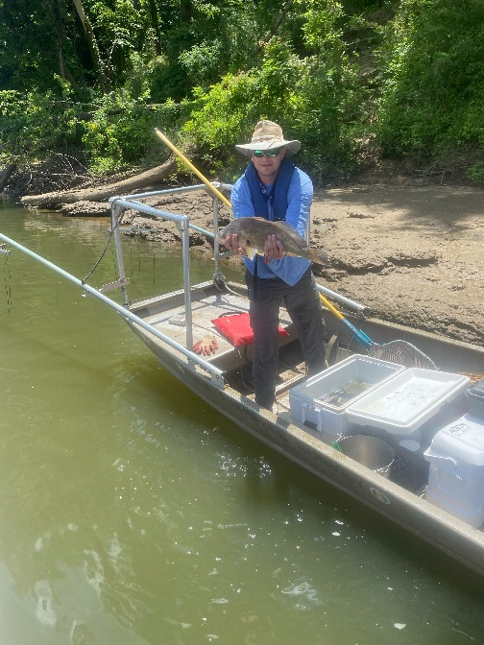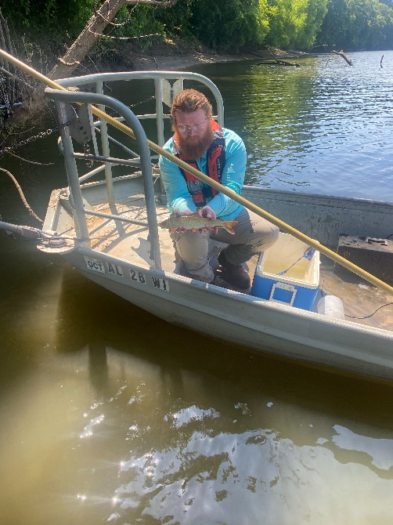
Figure 3: ADEM Biologist with fish captured during electrofishing efforts in June of 2023, Photo: USACE.

Target Species/Groups
This method is most effective for capturing resident, structure-oriented, large-bodied species. It is the primary and most effective gear for assessing populations of sport fish, including most basses (Micropterus spp.) and sunfishes (Lepomis spp.).

Site Selection
Following the IBI protocol, sampling sites were selected to represent the principal habitats of the river. The study area was stratified by river reach (Downstream of Claiborne, Claiborne Pool, Millers Ferry Pool) and habitat type (e.g., outside bend, inside bend, tributary mouth). Within these strata, standardized 500-meter shoreline sites were randomly selected for sampling.
Electrofishing was a primary tool for assessing the overall fish community, particularly for resident and sport fish populations. Across all river reaches, this method collected a total of 8,877 individuals. It was highly effective at capturing a broad range of species, providing the most comprehensive species list and establishing a robust baseline for the river's recreational fishery and general near-shore community health.
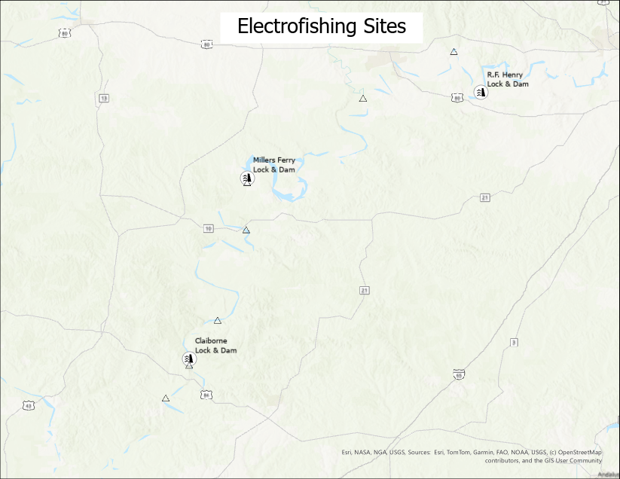
Figure 4: Sites sampled by electrofishing in FY 23.

Gravel Bar Seining

Method
Seining was conducted using a large, 40-foot by 6-foot bag seine with 1/4-inch mesh. This substantial piece of gear is specifically designed for sampling in large river systems where smaller seines would be ineffective. The seine is actively pulled by a crew of three to four people through a prescribed area to encircle and trap fish. The larger size and central bag (or "purse") ensure a high capture efficiency for a wide range of small-bodied fish and agile juveniles. Three to four biologists would pull the net moving downstream with the current and then start trailing towards the bank when 150 ft. of measured gravel bar was sampled. Fishes were then identified and released back into the river.
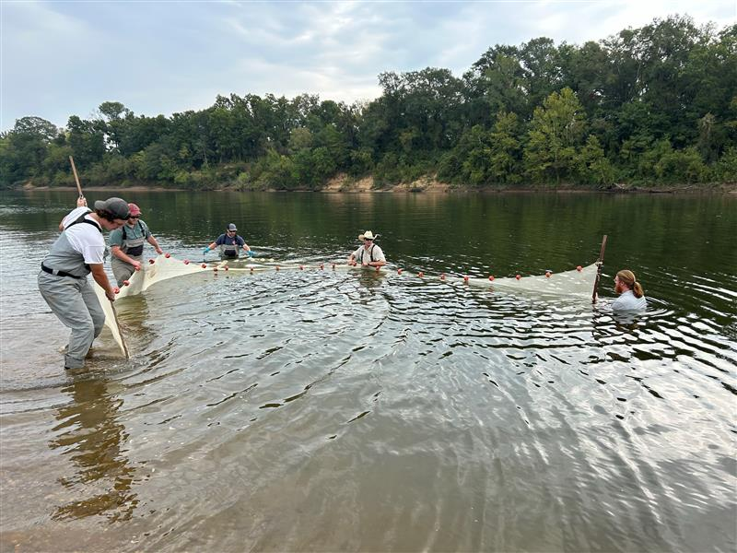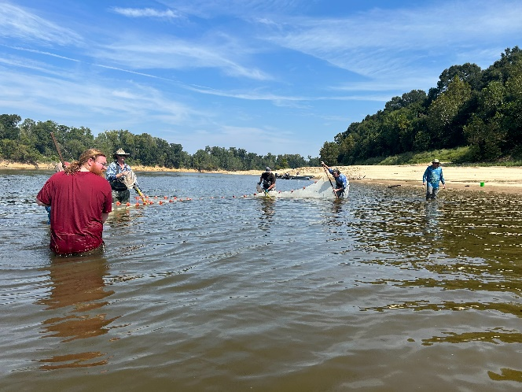
Figure 3: TNC, ADEM, and GSA biologist conduction beach seining in the Fall of 2023, Photo: TNC.

Site Selection
Seining sites were intentionally selected to sample shallow-water habitats (<5 feet deep) with low current velocity, primarily along the extensive margins of inundated sandbars and gravel bars. At each selected location, a standardized transect, 150 feet in length, was sampled with a single, comprehensive haul of the 40-foot seine. This targeted approach ensures a robust characterization of the near-shore fish community, which is a critical component of the river's overall biodiversity and food web.
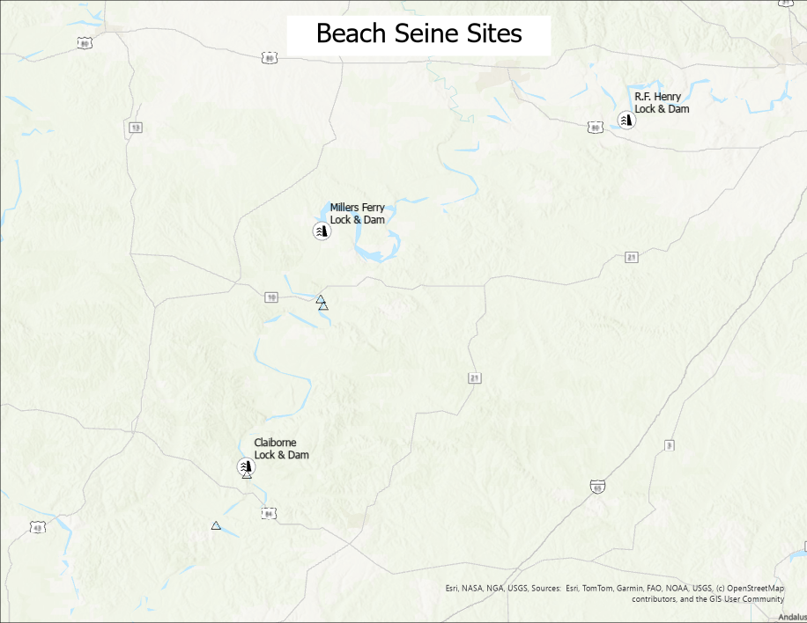
Figure 5: Sites sampled by seining in FY 23.

Target Species/Groups
Seining is the most effective method for capturing small-bodied fish, juvenile life stages of larger fish, and species that inhabit shallow, low-velocity edge habitats. Its primary targets are schooling cyprinids (shiners and minnows)

Results
The seining effort collected a total of 10,354 individuals. The catch was overwhelmingly dominated by small-bodied schooling cyprinids (minnows). This result is critical as it confirms the existence of a vast and healthy forage fish community in the river's shallow-water habitats, which is essential for sustaining the larger predator populations captured by other gears.

Trawling

Method
The multi-agency team utilized a Siamese trawl with an 8-foot mouth. A Siamese trawl is a specialized type of river trawl with two parallel nets, which increases sampling efficiency and provides replicate samples within a single tow. The catch from each trawl effort was placed in a live well, where all individuals were identified to species, recorded, and subsequently released. Each individual "trawl effort" consisted of towing the net for a duration of 5 to 10 minutes in water depths varying from 3 to 10 feet. To ensure precise spatial analysis, the start and end point of each trawl path was georeferenced using a GPS unit.

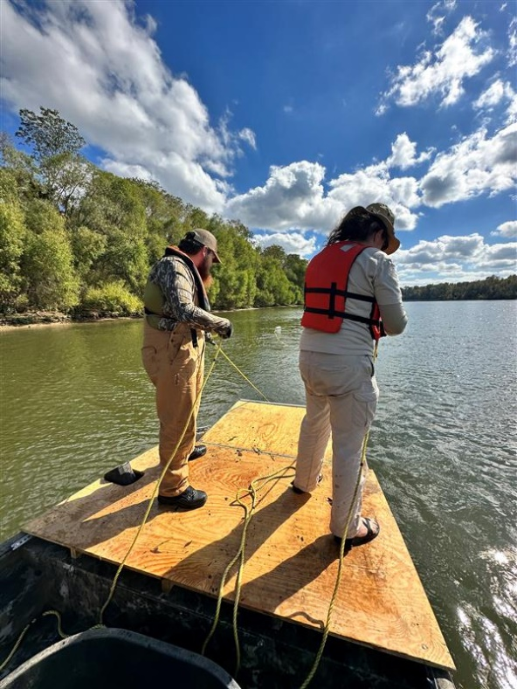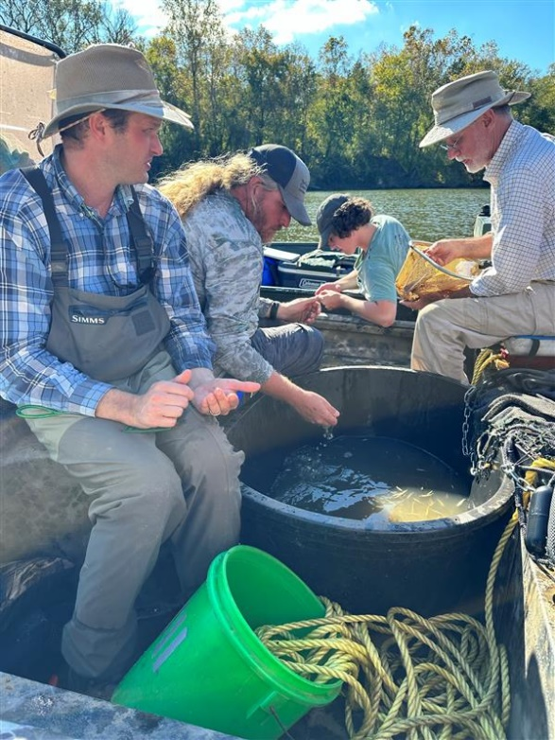
Figure 4: L: USACE and USFWS Biologist conducting a river trawl over a gravel bar in November of 2023. R: ADEM, TNC, and GSA biologists assessing fishes capture in November 2023, Photo: USACE.

Target Species/Groups
Trawling is specifically designed to capture benthic (bottom-dwelling) species that live on or near the substrate, particularly in the main river channel. It is highly effective for many small catfishes (madtoms), darters (Percina, Etheostoma), and substrate-oriented minnows.

Site Selection
Trawling efforts were conducted in the late fall and were intentionally targeted at historically mapped locations of inundated gravel bars and shoals. Trawling efforts were concentrated in the unimpounded reach Downstream of Claiborne Lock and Dam, where these natural features are most prevalent. Additional exploratory trawls were conducted at select locations within the Claiborne Pool and Millers Ferry Pool to determine if any functional shoal habitat remained post-impoundment. At each sampling station, multiple trawl efforts were made when bottom conditions (i.e., lack of snags) allowed.
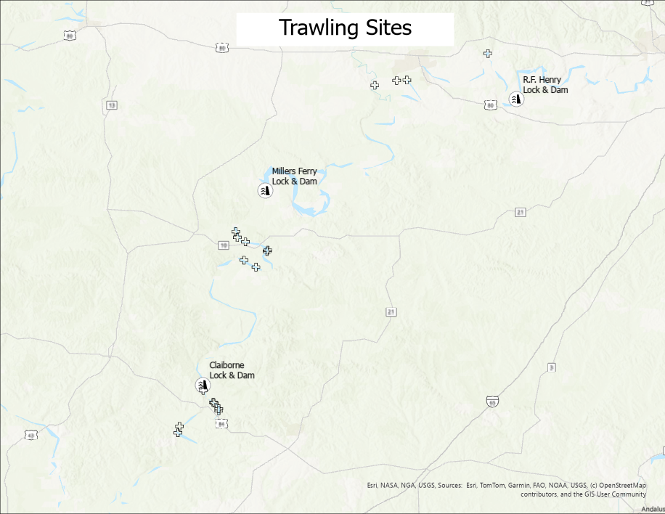
Figure 7: Sites sampled by trawling in FY 23.

Results
The trawling effort collected a total of 14,695 individuals. While this method captured a high number of fish, its most significant contribution was the documentation of rare, substrate-oriented species. This was the primary method that successfully documented the presence of the Crystal Darter, a high-priority conservation target, validating the continued ecological function of specific gravel bar habitats.

Data Analysis

To provide a deeper understanding of the community structure beyond simple abundance, biodiversity indices were calculated from the detailed, species-level GSA dataset and are presented in Table 2.

Calculation of Biodiversity Indices
To provide a quantitative measure of ecosystem health that incorporates both species richness and evenness, two standard ecological indices were calculated for each river reach. These calculations include sampled individuals from all three primary baseline sampling methods (Electrofishing, Trawling, and Gravel Bar Seining). This information is presented in Table 1.
Shannon Biodiversity Index (H): This index accounts for both the number of species and their relative abundance. Higher values indicate higher diversity. A value of 0 would represent a community with only one species.
Formula: H = -Σ (pᵢ * ln(pᵢ))
Where pᵢ is the proportion of the total sample belonging to the i-th species, calculated as: (Number of individuals of a single species) / (Total number of individuals of all species).
Simpson's Diversity Index (D): This index represents the probability that two individuals randomly selected from a sample will belong to different species. Values closer to 1 indicate higher diversity, while values closer to 0 indicate lower diversity.
Formula: D = 1 - Σ(nᵢ * (nᵢ - 1)) / (N * (N - 1))
Where nᵢ is the number of individuals of a single species, and N is the total number of individuals of all species.
Table 1: Shannon and Stimpson Biodiversity Indexes in each River Reach.
Metric | Downstream of Claiborne L&D | Between Claiborne & Millers Ferry L&Ds | Upstream of Millers Ferry L&D
Total Species (S) | 41 | 36 | 21
Shannon Index (H) | 1.83 | 2.12 | 1.22
Simpson's Index (D) | 0.69 | 0.81 | 0.59

Interpretation of Final Verified Results
The final, validated data from the FY23 baseline effort reveals a complex picture of a river system profoundly shaped by its impoundments. The analysis of both abundance and biodiversity across the three river reaches provides four key insights:
Hyper-Abundance in the First Impoundment: The most striking result is that the reach "Between Dams" (the Claiborne Pool) exhibited the highest total abundance by a massive margin (N=25,411). This staggering number is driven almost entirely by enormous catches in trawls and seines, indicating an explosive population of small-bodied species thriving in the stable, lake-like conditions of the first impoundment.
Highest Sport Fish Abundance is Downstream: While the impoundment had the highest total numbers, the free-flowing reach below Claiborne had the highest Electroboat catch (5,962 individuals) by more than double any other reach. As electrofishing is the primary method for capturing resident sport fish (e.g., bass, sunfish), this indicates that the unimpounded, natural river habitat supports the most robust population of these larger, structure-oriented species.
Cumulative Negative Impact Upstream: The "Upstream of Millers Ferry" reach had the lowest total abundance (N=2,194) and, critically, the lowest species richness (S=21) and the lowest diversity (H=1.22). This confirms the significant and cumulative negative impact of the second dam on the river's overall carrying capacity and ecological balance.
Diversity Does Not Follow Abundance: The data clearly shows that abundance is not a reliable indicator of ecosystem health in this system. The reach with the highest abundance ("Between Dams") was not the most diverse. The free-flowing downstream reach remains the reservoir of biodiversity, supporting the most unique species (S=41), while the "Between Dams" reach exhibited the highest "evenness" or balance among its species (H=2.12).

Discussion
The FY23 baseline investigation provides a clear and multi-faceted diagnosis of a large river ecosystem profoundly altered by its impoundments. The integrated analysis of the fish community reveals a system where the metrics of species richness, total abundance, and overall biodiversity tell three distinct but interconnected stories about the functional impact of the dams.
Species Richness: The Downstream Reservoir of Biodiversity
The data identifies the unimpounded, free-flowing reach below Claiborne Dam as the system's primary reservoir of biodiversity. This section supported the highest number of unique species (S=41). Critically, it was the only reach where many fluvial specialists and species of high conservation value, such as the Blue Sucker, River Redhorse, and Mobile Chub, were detected. This finding confirms that the natural, lotic habitat with its connected floodplain and diverse substrates is essential for maintaining the river's full, historical portfolio of species. The dams act as a powerful filter, and the downstream reach is the last section that retains this high level of native richness.
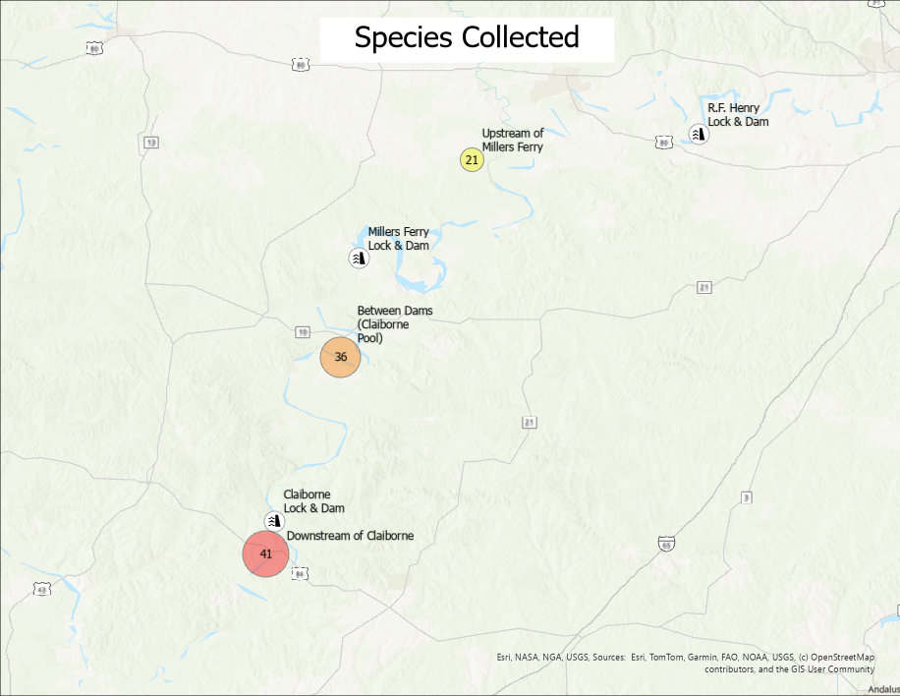
Figure 8: Total species collected in each reach.

Individuals Collected
A paradoxical relationship between abundance and other diversity metrics was observed. The Claiborne Pool, the first impoundment, yielded the highest total abundance (N=25,411), representing >74% of the total catch. This hyper-abundance is not indicative of superior ecosystem health but is a classic signature of an impoundment effect, wherein the creation of a stable, lentic environment facilitates the explosive proliferation of a few highly-adapted, r-selected species. This was driven primarily by massive catches of pelagic and benthopelagic cyprinids via seine and trawl. In contrast, the lowest total abundance was recorded in the uppermost impoundment (N=2,194), suggesting the cumulative effects of serial impoundment may suppress overall productivity for most sampled guilds.
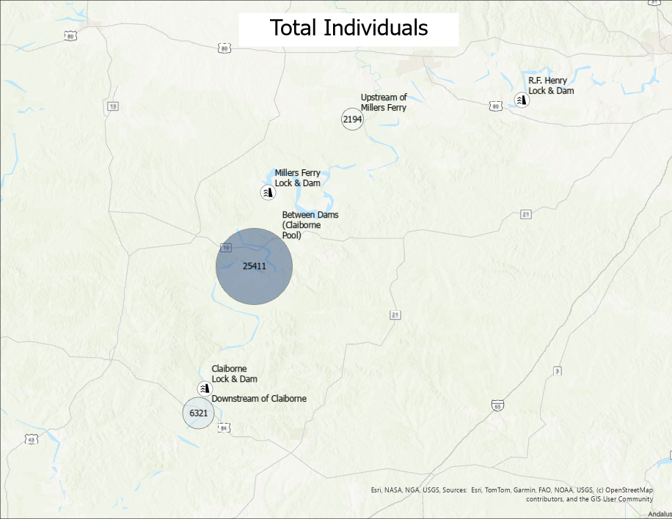
Figure 9: Total individuals collected in each reach.

Biodiversity Indices as a Measure of Community Structure and Balance
Integrated biodiversity indices provide a more nuanced assessment of community structure by incorporating both richness and evenness. The Millers Ferry Pool exhibited the lowest biodiversity (H=1.22), a result of its low species richness (S=21) coupled with the numerical dominance of a few generalist species. Conversely, the Claiborne Pool registered the highest diversity index (H=2.12), indicating the highest degree of evenness among the three reaches. This suggests that while this reach has experienced a loss of fluvial specialists, the remaining assemblage of generalist and transitional species has formed a relatively stable community structure. However, the downstream reach, which combines high species richness (S=41) with a healthy diversity score (H=1.83), represents the most desirable and natural ecological state.
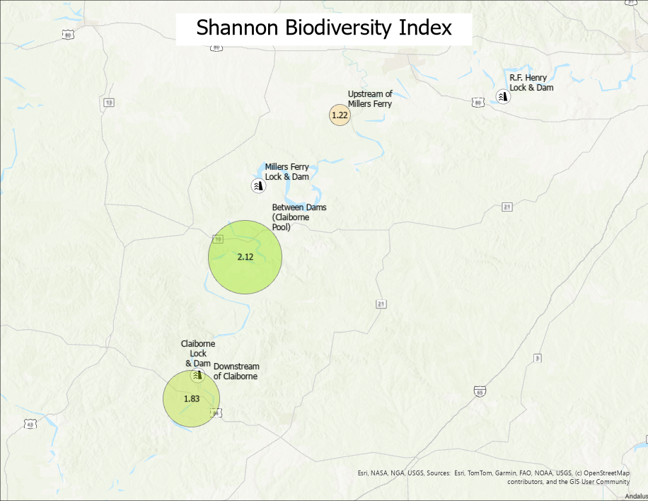
Figure 10: The Shannon Biodiversity Index for each Reach.
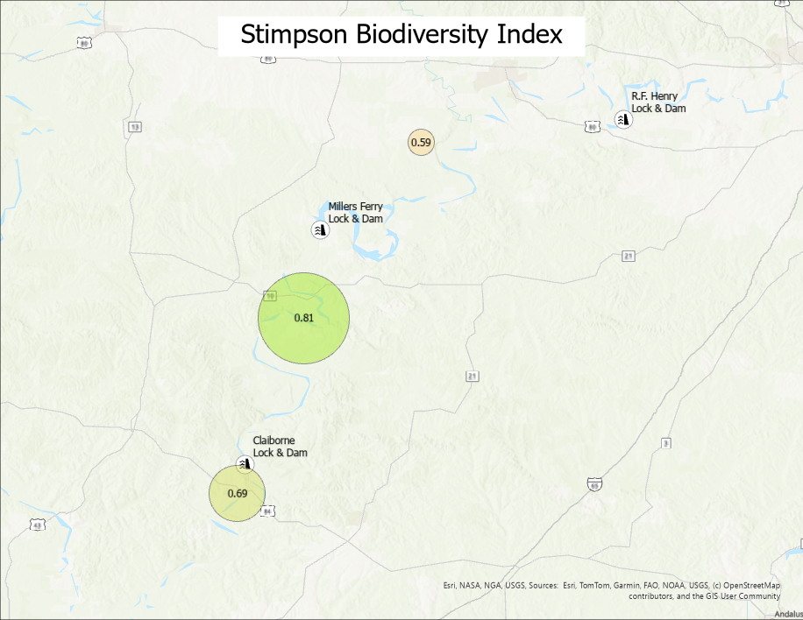
Figure 11: The Stimpson Biodiversity Index for each Reach.

Interpretation of Biodiversity Indices
To provide a robust and nuanced assessment of the fish community structure, two of the most widely accepted ecological diversity indices were calculated: the Shannon-Wiener Index (H) and the Simpson's Diversity Index (D). These indices are complementary; they both measure biodiversity, but they capture and emphasize different aspects of the ecosystem Table 2.
What They Both Measure:
At a basic level, both indices combine two key components of diversity:
Species Richness (S): The total number of different species in the community. A higher number of species will generally lead to a higher diversity score.
Species Evenness (E): The relative abundance of the different species. A community where all species have similar population sizes is considered "even" and will have a higher diversity score than a community where one or two species vastly outnumber all the others.

Table 2: Comparison of Shannon and Simpson's Diversity Indices
Index | Shannon-Wiener Index (H) | Simpson's Diversity Index (D)
Primary Emphasis | Richness and Evenness (Balanced) | Dominance
How it Works | It is an "information theory" index. It quantifies the uncertainty in predicting the species identity of an individual taken at random from the community. Higher uncertainty means higher diversity. | It is a "dominance" index. It quantifies the probability that two individuals taken at random from the community will belong to different species. A high probability means high diversity.
Sensitivity | It is more sensitive to the presence of rare species. The addition of a new, rare species will have a greater impact on the Shannon index than on the Simpson's index. | It is more sensitive to the abundance of the most common species. A community dominated by one or two super-abundant species will have a low Simpson's index, even if many rare species are present.
Value Range | Typically ranges from 1.5 to 3.5 in most ecological studies, but can go higher. A value of 0 means only one species is present. | Ranges from 0 to 1. A value of 0 means only one species is present. A value approaching 1 means very high diversity.
What it Tells You | Provides a well-rounded picture of the overall complexity of the community, giving weight to both the number of species and their distribution. It answers: "How complex and balanced is this ecosystem?" | Provides a clear picture of how dominated the community is by its most successful species. It answers: "How likely am I to encounter different species if I sample this community?"

Application in This Study
By using both indices, we gain a more complete understanding of the Alabama River's fish community.
- The Simpson's Index would be very low in the "Upstream of Millers Ferry" reach, demonstrating how that ecosystem is dominated by a few species like the Silverside Shiner.
- The Shannon Index being highest in the "Between Dams" reach highlights its relatively balanced structure, even if it has lost some rare species compared to the downstream reach.
Together, these indices provide a robust, quantitative, and scientifically defensible way to compare the ecological health of the different river sections, moving beyond simple species counts to a deeper understanding of community structure.

Discussion and Interpretation of Guild Analysis
When the fish community is analyzed by ecological guild, the functional impact of the dams becomes strikingly clear. The data reveals a powerful "filter effect," where the species most reliant on natural, free-flowing river habitats are progressively filtered out as you move upstream into the impoundments.
Table 3 summarizes the fish collected by guild collected in each reach. A break down of fish guilds is included in the Appendix (Species Classification by Primary Fish Guild).
Table 3: Summary of fish collected by guild.
Ecological Guild | Downstream of Claiborne | Between Dams (Claiborne Pool) | Upstream of Millers Ferry
A. Fluvial Specialists & Migrants | 1,057(16.7%) | 211(0.8%) | 11(0.5%)
B. Resident Predators | 3,124(49.4%) | 1,098(4.3%) | 346(15.8%)
C. Benthic Species | 988(15.6%) | 13,299(52.3%) | 152(6.9%)
D. Generalist Forage Species | 1,152(18.2%) | 10,803(42.5%) | 1,685(76.8%)
Total Individuals (N) | 6,321 | 25,411 | 2,194

- Fluvial Specialists are Filtered: The most dramatic finding is the severe decline of the Fluvial Specialists & Large-River Migrants guild upstream of the dams. Iconic riverine species like the Blue Sucker, River Redhorse, and Southern Walleye were only found in the unimpounded reach below Claiborne Dam. This provides strong evidence that Claiborne Dam acts as a major barrier to the distribution of many species characteristic of a healthy, large river system.
- The Significance of the Crystal Darter Finding: The detection of the Crystal Darter both downstream of Claiborne and in the first impoundment ("Between Dams") is a finding of profound conservation significance. It indicates that a relict, and likely isolated, population has managed to persist in the Claiborne Pool for decades post-impoundment. This proves that some functional, high-quality gravel and sand bar habitat must still exist within the impoundment. However, their absence above Millers Ferry Dam suggests this second barrier represents a final, insurmountable obstacle for this vulnerable population, isolating them from any potential upstream habitats. Protecting the specific locations of these captures in the Claiborne Pool is now a critical management priority.
- Generalists Persist: In stark contrast to the specialists, guilds composed of more adaptable species persist across all three reaches. Riverine Predators like bass and Bluegill, and Generalist Forage Species like Gizzard Shad and various shiners, were found in all three sections. Their ability to thrive in both river (lotic) and lake (lentic) environments allows them to inhabit the impoundments, though their community structure changes.
- Loss of Benthic Diversity: The benthic community also shows a clear decline in richness. Many darter species, which rely on clean, flowing water over gravel and sand substrates, disappear in the upstream reaches where these habitats have been replaced by slower water and increased siltation.
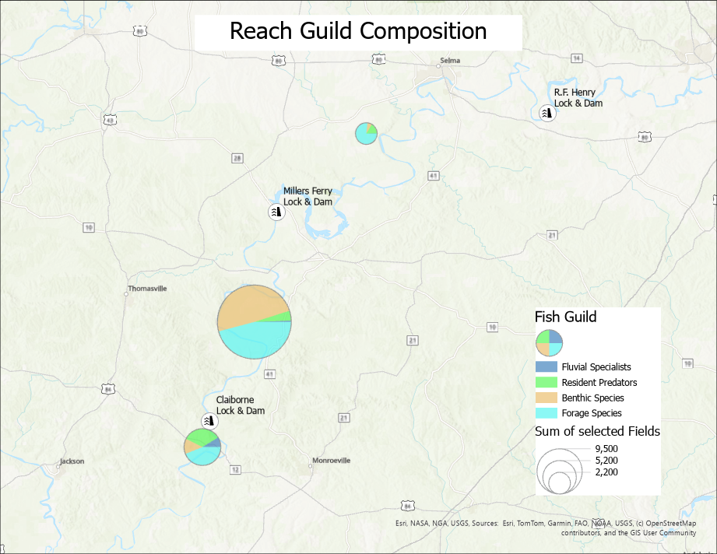
Figure 12: The guild composition of each reach.

A Comparative Analysis of Pre- and Post-Impoundment Fish Assemblage Dynamics
The primary objective of the FY23 baseline investigation was to provide a modern, quantitative assessment of the Alabama River fish assemblage and to infer the long-term ecological impacts of impoundment. By integrating our contemporary field data (2023) with historical species accounts (Mettee, O'Neil, Shepard, & McGregor, 2005) and recent archival research on the pre-dam ichthyofauna (Hershey , Wright, Williams, O'Neil, & DeVries, 2024), we can construct a comparative analysis that reveals the fundamental shifts in the river's community structure. This diachronic comparison illustrates a clear ecological trajectory from an open, lotic system to a regulated, fragmented one.

Shift in Community Structure and Dominance
The pre-impoundment Alabama River functioned as an open migratory corridor where the fish assemblage was structured around species adapted to a dynamic, flowing-water environment. Historical accounts describe massive, seasonal "runs" dominated by large-bodied, potamodromous species, including sturgeon (Acipenser, Scaphirhynchus), shad (Alosa), and large catostomids (Ictiobus, Moxostoma), which were keystone components of the ecosystem and supported significant commercial fisheries.
The current state, as quantified by the FY23 baseline data, is that of a series of semi-permeable filters that have precipitated a fundamental shift in community dominance. The impounded reaches are now numerically dominated by lentic-adapted generalist species. The hyper-abundance of individuals (N=25,411) observed in the Claiborne Pool is a classic signature of this impoundment effect, driven by the proliferation of a few highly successful, small-bodied forage species, with the Silverside Shiner (Notropis candidus) being a primary example. This represents a shift from a system historically defined by large-bodied migrants to one now numerically dominated by small, ubiquitous generalists in its altered sections.

Truncation of Fluvial Specialist Distribution
The most direct and quantifiable impact of the dams has been on the distribution of fluvial specialist species.
Obligate Migrants: Species described by Mettee et al. as requiring extensive, free-flowing river habitats for life cycle completion are now largely confined to the unimpounded reach below Claiborne Dam. Our FY23 survey data confirms this, with species such as the Blue Sucker (Cycleptus elongatus) and River Redhorse (Moxostoma carinatum) being detected only in this downstream reach. Their absence from the upstream impoundments provides direct empirical evidence that the dams act as significant barriers to their dispersal.
Benthic Specialists: The status of rare, benthic specialists serves as a critical indicator of habitat integrity. While historical distributions were likely widespread, Mettee et al. noted their severe fragmentation post-impoundment. Our targeted trawling confirmed the presence of the Mobile Chub (Macrhybopsis sp.) only in the downstream reach. However, the detection of a relict population of the Crystal Darter (Crystallaria asprella) within the Claiborne Pool is a significant finding. It indicates that pockets of functional, clean-substrate habitat persist even within the impounded zone, though this population is likely isolated from its downstream counterpart and any potential upstream habitats.

Functional Extirpation of Keystone Species
The comparison for sturgeon is particularly stark. Described by Hershey et al. as a cornerstone of pre-dam commercial fisheries far upstream, their populations were noted as "decimated" by Mettee et al. following dam construction. The non-detection of any sturgeon species in our comprehensive, multi-gear 2023 survey, despite methods capable of capturing them, provides strong evidence that they are functionally extirpated from the study area above the lowermost reach, their long-distance migrations having been blocked for over 50 years.

Synthesis
This comparative analysis demonstrates that the current fish community of the Alabama River is a direct product of the ecological "filter effect" imposed by the dams. The system has shifted from one defined by the widespread movement of large-bodied, potamodromous species to one characterized by fragmented populations and the numerical dominance of lentic-adapted generalists in its impounded sections. The SRP's subsequent investigations into fish passage are therefore not aimed at creating an artificial process, but at restoring a vestige of the river's historical, natural function by providing a pathway for the remnant specialist and migratory guilds to bypass these long-standing barriers.

Future Application of this Baseline Analysis
The quantitative biodiversity analysis performed in this FY23 study is not merely a static, descriptive endpoint; it is the foundational quantitative benchmark that enables and validates all subsequent and future restoration efforts on the Alabama River. Its primary utility is as a permanent, scientifically-defensible baseline representing the "before" state of the fragmented system, against which the efficacy of any management intervention can be rigorously measured.

The applications of this baseline are threefold:

- Providing a Statistical Basis for Measuring Success: The calculated diversity indices (Shannon 'H' and Simpson's 'D') and species richness (S) values for each river reach serve as the control data in a long-term ecological experiment. Following the implementation of management actions, such as the event-based conservation lockages investigated in FY24/25, these same river reaches can be resampled using the same multi-gear methodology. A statistically significant increase in the species richness and Shannon Index in the impounded reaches, particularly the "Upstream of Millers Ferry" section, would provide quantitative proof that the program is successfully restoring ecological connectivity.
- Moving Beyond Simple Passage to Ecological Recovery: This baseline allows for a more sophisticated definition of success. Instead of simply counting the number of fish passed through a lock, success can be measured as a functional improvement in the upstream ecosystem. The analysis allows us to ask more meaningful questions: Are fluvial specialists re-colonizing the impounded reaches? Is the hyper-dominance of forage species in the Claiborne Pool being tempered by the reintroduction of migratory predators? This allows us to move beyond measuring an action (passage) and toward measuring the desired outcome (true ecological recovery).
- Informing an Adaptive Management Framework: This dataset is the engine for adaptive management. If future monitoring reveals that only certain species or guilds are successfully moving upstream, the baseline data allows us to identify which groups are being left behind. This provides the feedback loop necessary to refine the management strategy. For example, if darters and other benthic species show no improvement upstream, it may indicate a need for habitat restoration in the impoundments in addition to passage, a conclusion only possible with a comprehensive baseline.

Future Direction
The findings of the FY23 baseline study provided an unambiguous mandate for the next phase of the investigation. Having quantitatively diagnosed a fragmented system with suppressed biodiversity, the project pivoted from broad-scale characterization to a focused, hypothesis-driven investigation at the points of impediment. The primary objective for FY24 and FY25 was to elucidate the specific mechanisms of migratory blockage and test the viability of a non-structural passage solution:
Targeted Sampling to Intercept Migratory Aggregations: In FY24 and FY25, the project focused exclusively on the spring migratory season. The team conducted high-effort gill netting surveys specifically in the immediate tailwaters and lock approaches of Claiborne and Millers Ferry dams. This methodology was chosen to directly test the hypothesis that the "missing" migratory species identified in the baseline were not absent from the system, but were forming dense, pre-passage aggregations at the barriers.
Tagging Program to Document Movement: To move from documenting aggregations to proving passage, a robust tagging program was implemented. Fish captured in the gill net surveys were tagged with individually numbered external "Floy" tags. This tagging effort was designed to provide direct, empirical evidence of individual movement, answering the critical question: can fish physically navigate the lock structures?
Public Angler Engagement: To expand the spatial and temporal scope of the recapture effort, the team initiated an outreach program to utilize data from public anglers who recaptured tagged fishes. This citizen-science component provides an invaluable, low-cost method for documenting long-range dispersal away from the dam sites.
Integration with Environmental Data: The data collected on fish presence and movement was then quantitatively compared to real-time environmental data (hydrograph and temperature) from USGS gages. This was designed to test the central hypothesis that migration is not random but is triggered by specific, predictable environmental cues.
The data collected in these subsequent phases was then directly compared to the community structures documented in this FY23 report. This allowed for a powerful synthesis: by understanding the composition of the general river community (FY23) and then identifying the specific subset of that community that actively attempts to migrate past the dams (FY24/25), a highly targeted and efficient management strategy could be developed.

Bibliography
Hershey , H. J., Wright, R. A., Williams, J. D., O'Neil, P. E., & DeVries, D. R. (2024). Pre-impoundment fish migrations in the Mobile Basin, Alabama. Ecology of Freshwater Fish.
Mettee, M. F., O'Neil, P. E., Shepard, T. E., & McGregor, S. W. (2005). A STUDY OF FISH MOVEMENTS AND FISH PASSAGE AT CLAIBORNE AND MILLERS FERRY LOCKS AND DAMS ON THE ALABAMA RIVER, ALABAMA. OPEN-FILE REPORT 0507.
USACE/ TNC. (2021). Sustainable Rivers Program- Program Management.

Appendix

Collected Data

Species Classification by Primary Fish Guild
Species | Primary Guild Assignment | Rationale
--- Fluvial Specialists & Migrants ---
Alabama Hog Sucker | A. Fluvial Specialist | Requires flowing water and clean substrate.
Blue Sucker | A. Fluvial Specialist | Iconic large-river, strong-current species.
Highfin Carpsucker | A. Fluvial Specialist | Large-river sucker, known to be migratory.
Paddlefish | A. Fluvial Specialist | Large-river, pelagic, highly migratory.
River Carpsucker | A. Fluvial Specialist | Prefers main channels of large rivers.
River Redhorse | A. Fluvial Specialist | Requires clean gravel for spawning in flowing water.
Shorthead Redhorse | A. Fluvial Specialist | Migratory, requires flowing water.
Silver Redhorse | A. Fluvial Specialist | Migratory, prefers large rivers.
Skipjack Herring | A. Fluvial Specialist | Highly migratory, open-water pelagic species.
Smallmouth Buffalo | A. Fluvial Specialist | Large-river, migratory, key commercial species.
Southern Walleye | A. Fluvial Specialist | Extremely rare, requires cool, flowing water.
Striped Bass | A. Fluvial Specialist | Anadromous/potamodromous, highly migratory.
White Bass | A. Fluvial Specialist | Known for long-distance spring spawning runs.
Wiper Bass | A. Fluvial Specialist | Hybrid, but functionally a large, migratory predator.
--- Resident Predators (Sport Fish & Other) ---
Alabama Bass | B. Resident Predator | Key sport fish, structure-oriented.
Black Crappie | B. Resident Predator | Sport fish, prefers slower water/structure.
Blue Catfish | B. Resident Predator | Large-river predator, but more generalist than specialists.
Bluegill | B. Resident Predator | Ubiquitous sport fish, littoral/structure-oriented.
Bowfin | B. Resident Predator | Ambush predator of slow-moving backwaters.
Channel Catfish | B. Resident Predator | Generalist predator found in all habitats.
Flathead Catfish | B. Resident Predator | Large-river apex predator, structure-oriented.
Largemouth Bass | B. Resident Predator | Key sport fish, thrives in slower, vegetated habitats.
Longear Sunfish | B. Resident Predator | Common sunfish, generalist.
Longnose Gar | B. Resident Predator | Generalist ambush predator.
Redear Sunfish | B. Resident Predator | Common sunfish, often benthic-feeding.
Spotted Bass | B. Resident Predator | Key sport fish, prefers current more than Largemouth.
Spotted Gar | B. Resident Predator | Generalist ambush predator.
Warmouth | B. Resident Predator | Sunfish of slow, weedy habitats.
White Crappie | B. Resident Predator | Sport fish, prefers slower water/structure.
--- Benthic Species (Bottom-Dwelling) ---
Black Spotted Darter | C. Benthic Species | Darter, lives on substrate.
Blacktail Redhorse | C. Benthic Species | While a sucker, more of a generalist benthic feeder.
Channel Darter | C. Benthic Species | Classic inhabitant of sand/gravel runs.
Crystal Darter | C. Benthic Species | Re-assigned: Its primary functional role is as a benthic specialist.
Freckled Darter | C. Benthic Species | Darter, lives on substrate.
Freshwater Drum | C. Benthic Species | Primarily a bottom-feeder on mollusks.
Logperch | C. Benthic Species | Unique darter that flips stones to feed.
Orangetail Darter | C. Benthic Species | Darter, lives on substrate.
Quillback | C. Benthic Species | Benthic-feeding carpsucker.
River Darter | C. Benthic Species | Darter, lives on substrate.
Southern Madtom | C. Benthic Species | Small, nocturnal, benthic catfish.
Speckled Darter | C. Benthic Species | Darter, lives on substrate.
Spotted Sucker | C. Benthic Species | While a sucker, less migratory than buffalo/redhorse.
--- Generalist Forage Species (Pelagic/Littoral) ---
Bigeye Chub | D. Forage Species | Small minnow.
Bullhead Minnow | D. Forage Species | Ubiquitous, tolerant minnow.
Emerald Shiner | D. Forage Species | Pelagic, schooling minnow.
Ghost Shiner | D. Forage Species | Small minnow.
Gizzard Shad | D. Forage Species | Ubiquitous, pelagic, critical forage base.
Golden Shiner | D. Forage Species | Common baitfish, often in weedy areas.
Mobile Chub | D. Forage Species | Re-assigned: Its primary functional role is as a small forage fish.
Mosquitofish | D. Forage Species | Surface-dwelling, tolerant generalist.
Pugnose Minnow | D. Forage Species | Small minnow of weedy, slow waters.
Silver Chub | D. Forage Species | Often found in large schools in the main channel.
Silverstripe Shiner | D. Forage Species | Common schooling minnow.
Silverside Shiner | D. Forage Species | Abundant, pelagic, schooling minnow.
Threadfin Shad | D. Forage Species | Ubiquitous, pelagic, critical forage base.
Weed Shiner | D. Forage Species | Small minnow of weedy, slow waters.

Master Fish Species Inventory by River Reach (FY23 Baseline)
This table details the presence (✓) or absence of all 54 fish species captured during the 2023-2024 baseline sampling effort across the three major river reaches. This format clearly illustrates the decline in species richness and the selective removal of specialist species as one moves upstream through the impounded system.
Fish Species | Downstream of Claiborne | Between Dams (Claiborne Pool) | Upstream of Millers Ferry
Alabama Bass | ✓ | ✓ | ✓
Alabama Hog Sucker | ✓
Bigeye Chub | ✓
Black Crappie | ✓ | ✓ | ✓
Black Spotted Darter | ✓ | ✓
Blacktail Redhorse | ✓ | ✓ | ✓
Blue Catfish | ✓ | ✓
Blue Sucker | ✓
Bluegill | ✓ | ✓ | ✓
Bowfin | ✓
Bullhead Minnow | ✓ | ✓ | ✓
Channel Catfish | ✓ | ✓ | ✓
Channel Darter | ✓ | ✓ | ✓
Crystal Darter | ✓ | ✓
Emerald Shiner | ✓ | ✓ | ✓
Flathead Catfish | ✓ | ✓
Freckled Darter | ✓
Freshwater Drum | ✓ | ✓ | ✓
Ghost Shiner | ✓ | ✓
Gizzard Shad | ✓ | ✓ | ✓
Golden Shiner | ✓
Highfin Carpsucker | ✓ | ✓
Largemouth Bass | ✓ | ✓ | ✓
Logperch | ✓
Longear Sunfish | ✓ | ✓ | ✓
Longnose Gar | ✓ | ✓
Mobile Chub | ✓
Mosquitofish | ✓ | ✓ | ✓
Paddlefish | ✓ | ✓
Pugnose Minnow |  | ✓
Quillback | ✓ | ✓ | ✓
Redear Sunfish | ✓ | ✓
River Carpsucker | ✓
River Darter | ✓ | ✓ | ✓
River Redhorse | ✓
Shorthead Redhorse | ✓
Silver Chub | ✓ | ✓ | ✓
Silver Redhorse | ✓
Silverstripe Shiner | ✓ | ✓ | ✓
Silverside Shiner | ✓ | ✓ | ✓
Skipjack Herring | ✓ | ✓
Smallmouth Buffalo | ✓ | ✓ | ✓
Southern Madtom | ✓
Southern Walleye | ✓
Speckled Darter | ✓ | ✓
Spotted Bass | ✓ | ✓ | ✓
Spotted Gar | ✓ | ✓
Spotted Sucker | ✓ | ✓ | ✓
Striped Bass | ✓
Threadfin Shad | ✓ | ✓ | ✓
Warmouth | ✓
Weed Shiner |  | ✓
White Bass | ✓ | ✓
White Crappie | ✓ | ✓ | ✓
Wiper Bass | ✓ | ✓
Total Fish Species (S) | 40 | 35 | 21

